

College of Computer Science and Engineering
Customer Churn Prediction Using Machine Learning
CCDS 322 – Applied Machine Learning

Prepared by:
[Raghad Abdulrahman Baafif 2310343]
[Dalia Essa Alqahtani 2310316]
[Ghala Mohammed Alzahrani 2317323]
[Aryam Mohammed 2310509]

1. Introduction
Customer churn is one of the most important challenges faced by telecommunications companies. Customer churn occurs when customers stop using a company’s services and move to another provider. Losing customers can negatively affect company profits and business performance. Therefore, companies try to understand customer behavior and identify the reasons why customers leave their services.
Machine learning techniques can help companies analyze customer information and predict whether a customer is likely to leave the company or remain as a customer. Predicting customer churn helps companies improve customer retention strategies, increase customer satisfaction, and reduce financial losses.
In this project, different machine learning algorithms were applied to predict customer churn using a real telecom customer dataset. The project included data analysis, preprocessing, model building, evaluation, and comparison between multiple machine learning models.

2. Goal of the Project
The main goal of this project is to predict whether a customer will leave the telecom company or stay using machine learning techniques.
The project also aims to:
Analyze customer behavior. -
Understand the factors that affect customer churn. -
Compare the performance of different machine learning algorithms. -
Identify the most suitable model for customer churn prediction. -

3. Dataset Description
The dataset used in this project is the Telco Customer Churn dataset obtained from Kaggle.
This dataset contains customer information collected from a telecommunications company. The dataset includes 7032 customer records and 20 columns that describe customer characteristics and service details.
Some important attributes in the dataset include:
- Gender
Senior citizen status -
-Contract type
-Internet service
-Monthly charges
-Payment method
-Customer tenure
-Churn status
The target variable in this dataset is:
Churn
The “Churn” column indicates whether the customer left the company or remained with the service.
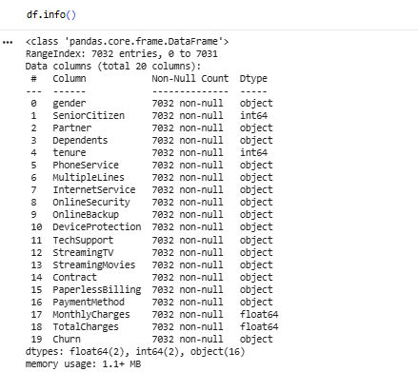
The dataset contains both numerical and categorical attributes, making it suitable for classification problems using machine learning algorithms.

4. Why This Dataset Was Chosen
This dataset was chosen because customer churn prediction is an important real-world business problem. The dataset contains realistic customer information that can help analyze customer behavior and identify patterns related to customer retention.
In addition, the dataset is well-structured and suitable for applying machine learning classification algorithms. It also contains different types of features that allow meaningful data analysis and visualization.

5. Hypotheses
The following hypotheses were developed before building the machine learning models:
-Customers with month-to-month contracts are more likely to churn.
Customers with higher monthly charges are more likely to leave the company. -
New customers are more likely to churn compared to long-term customers. -
-Customers with fiber optic internet service may have a higher churn rate.
-Customers using electronic payment methods may churn more frequently.
These hypotheses were tested through data visualization and machine learning analysis.

6. Tools and Libraries
The following tools and libraries were used to complete this project:
Tools
- Google Colab
- Python
Python Libraries
- Pandas
- NumPy
- Matplotlib
- Seaborn
- Scikit-learn
Google Colab was used as the development environment because it allows easy execution of Python code online without requiring software installation.
Pandas and NumPy were used for data handling and preprocessing. Matplotlib and Seaborn were used for data visualization. Scikit-learn was used for machine learning model building and evaluation.

7. Exploratory Data Analysis (EDA)
Exploratory Data Analysis was performed to better understand the dataset and identify important patterns related to customer churn.
Several visualizations were created to analyze customer behavior and relationships between variables.

7.1 Churn Distribution
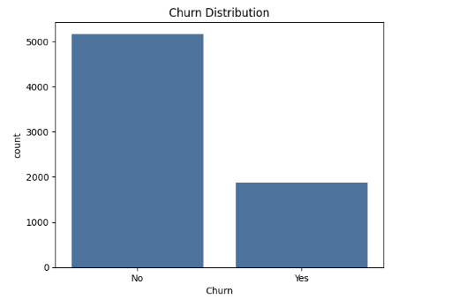
(Churn Distribution chart)
The figure shows the distribution of customers who stayed and customers who left the company.
Most customers remained with the company, while a smaller number of customers left the service. This indicates that the dataset is slightly imbalanced because the number of non-churn customers is larger than churn customers.
Understanding the distribution of churn helps evaluate the classification performance of machine learning models.

7.2 Contract Type vs Churn
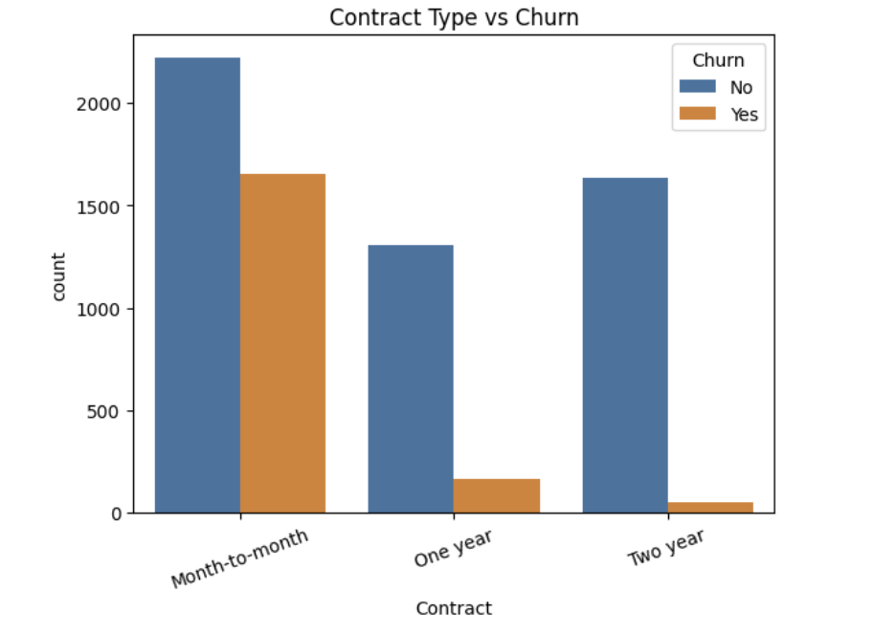
(Contract Type vs Churn chart)
The figure shows the relationship between contract type and customer churn.
Customers with month-to-month contracts have the highest churn rate compared to customers with one-year or two-year contracts. Long-term contract customers appear more likely to remain with the company.
This result supports the hypothesis that customers without long-term contracts are more likely to leave the company.

7.3 Monthly Charges vs Churn
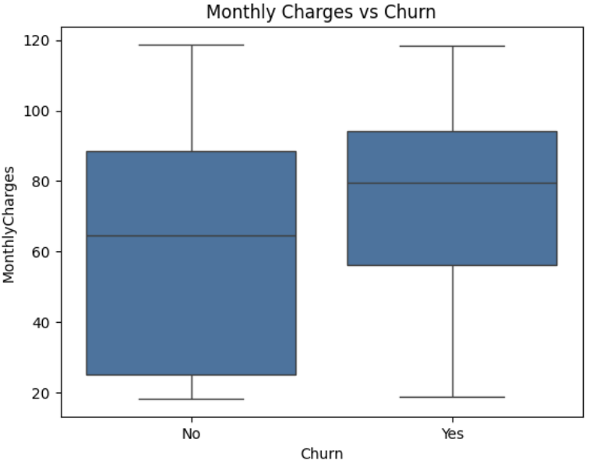
(Monthly Charges vs Churn chart)
The figure shows the relationship between monthly charges and customer churn.
Customers who left the company generally had higher monthly charges compared to customers who stayed with the service. Higher service costs may contribute to customer dissatisfaction and increase the probability of churn.
The visualization confirms that monthly charges are an important feature in predicting customer churn.

8. Data Preprocessing
Before building machine learning models, several preprocessing steps were applied to prepare the dataset for analysis.
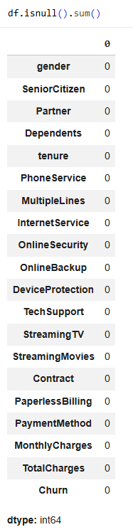The preprocessing steps included:

8.1 Handling Missing Values
Missing values were checked using the isnull() function. Rows containing missing values were removed to improve data quality and ensure reliable model training.
8.2 Encoding Categorical Variables
Categorical values such as “Yes” and “No” were converted into numerical values using encoding techniques. This step is necessary because machine learning models require numerical input data.

8.3 Splitting the Dataset
The dataset was divided into:
- Training set (80%)
- Testing set (20%)
The training set was used to train the machine learning models, while the testing set was used to evaluate model performance.
8.4 Feature Scaling
Feature scaling was applied using StandardScaler to normalize numerical values and improve the performance of machine learning algorithms.

9. Machine Learning Models
Three machine learning classification algorithms were applied in this project to predict customer churn.

9.1 Logistic Regression
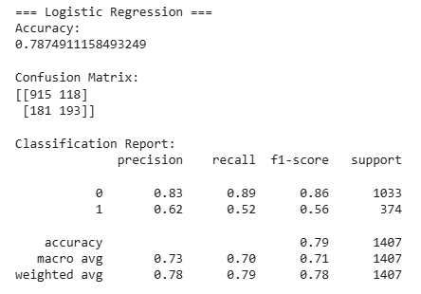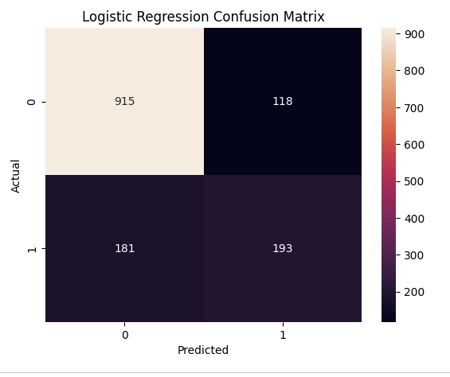

- Logistic Regression Results
- Logistic Regression Confusion Matrix
Logistic Regression achieved an accuracy of approximately 78%.
The confusion matrix and classification report show that the model performed well in distinguishing between churn and non-churn customers.
The model produced balanced classification results and showed good overall performance for customer churn prediction.

9.2 Decision Tree
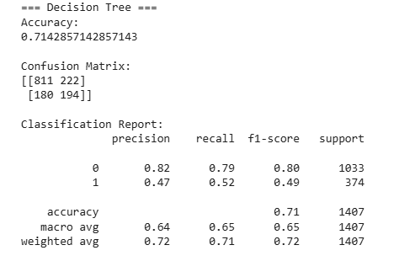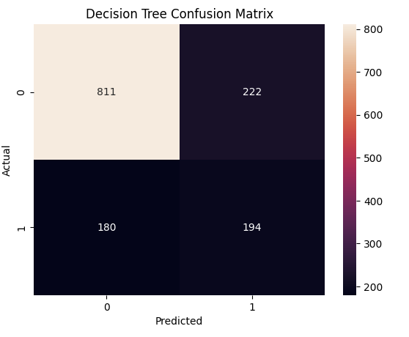

- Decision Tree Results
- Decision Tree Confusion Matrix
Decision Tree achieved an accuracy of approximately 71%.
The model was able to classify customer churn but produced lower performance compared to Logistic Regression and Random Forest.
Although Decision Tree is simple and easy to interpret, it may suffer from overfitting and reduced generalization performance.

9.3 Random Forest
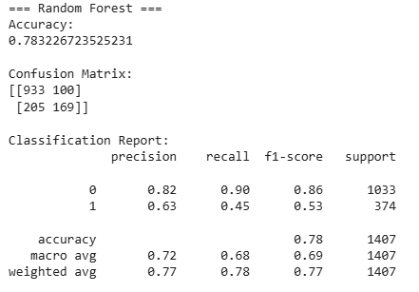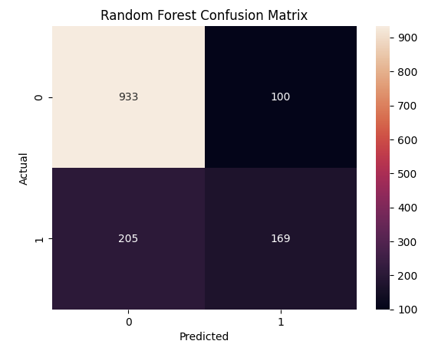

- Random Forest Results
- Random Forest Confusion Matrix
Random Forest achieved an accuracy of approximately 78%.
The model performed well in predicting customer churn and produced strong classification results. Random Forest combines multiple decision trees, which helps improve prediction accuracy and reduce overfitting.
The model achieved performance very close to Logistic Regression.

9.4 XGBoost
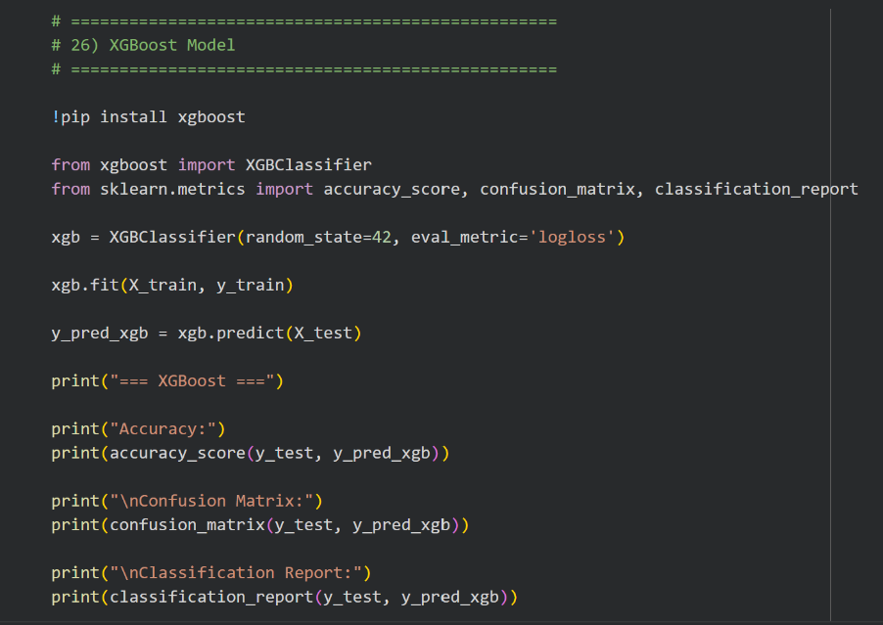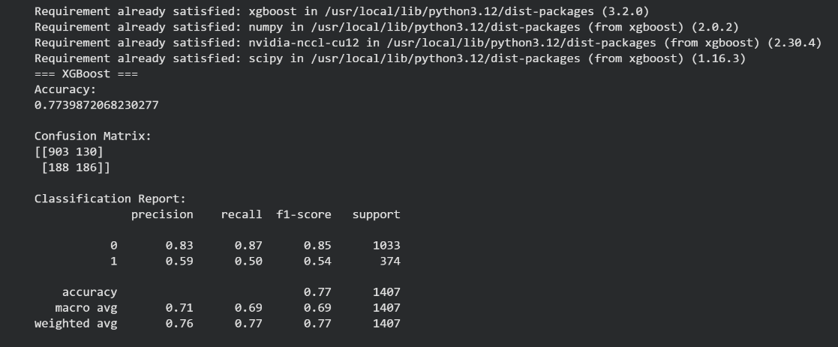

• XGBoost Results
• XGBoost Confusion Matrix
XGBoost was implemented as an additional machine learning model to improve the overall comparison between algorithms.
The model achieved an accuracy of approximately 77% and produced competitive classification results. The confusion matrix and classification report showed that XGBoost performed effectively in predicting customer churn and achieved results close to Logistic Regression and Random Forest.

10. Results Comparison
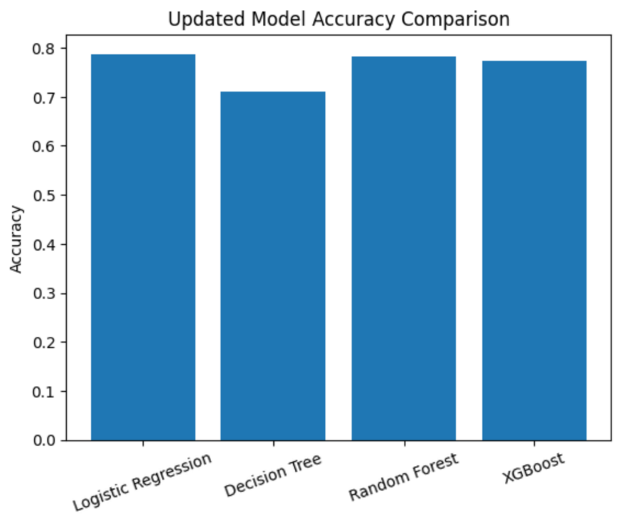

Model | Accuracy | Advantages | Disadvantages
Logistic Regression | 78% | Simple and fast | Cannot capture complex patterns
Decision Tree | 71% | Easy to interpret | Overfitting risk
Random Forest | 78% | High accuracy and reduced overfitting | More complex
XGBoost | 77% | Strong predictive performance | Higher computational cost
The comparison results show that Logistic Regression and Random Forest achieved the highest accuracy among all models. Logistic Regression was selected as the best-performing model because it provides balanced classification performance, faster training time, and easier interpretability. Although Random Forest achieved similar accuracy, it is more complex and computationally expensive. XGBoost also demonstrated strong predictive capability with competitive accuracy results.

11. Best Model
Based on the evaluation results, Logistic Regression was selected as the best-performing model due to its high accuracy and balanced classification performance.
Random Forest and XGBoost also achieved strong results and demonstrated effective customer churn prediction capability.

12. Ethical Considerations
Customer data should be handled responsibly and personal information must remain private.
Machine learning systems should avoid biased predictions and ensure fairness for all customers regardless of gender, age, or service type.
In addition, customer data must be protected from unauthorized access, and machine learning predictions should be used ethically to support decision-making without harming customers.
In addition, machine learning systems should maintain transparency and explainability when making predictions. Incorrect predictions may negatively affect customer relationships or business decisions. Therefore, companies must ensure responsible use of predictive models and continuously monitor model fairness and accuracy to avoid discrimination against specific customer groups.

13. Conclusion
Four machine learning algorithms were implemented and evaluated in this project:
• Logistic Regression
• Decision Tree
• Random Forest
• XGBoost
The results showed that Logistic Regression and Random Forest achieved the highest performance, while XGBoost also produced competitive results and enhanced the overall comparison between machine learning models.

14.References
Kaggle. Telco Customer Churn Dataset.
https://www.kaggle.com/
Scikit-learn Documentation.
https://scikit-learn.org/
Pandas Documentation.
https://pandas.pydata.org/
Seaborn Documentation.
https://seaborn.pydata.org/

